

See discussions, stats, and author profiles for this publication at: [https://www.researchgate.net/publication/337388411](https://www.researchgate.net/publication/337388411_IEEE_paper?enrichId=rgreq-ac03bf2fe4f1238240a6a3068062f789-XXX&enrichSource=Y292ZXJQYWdlOzMzNzM4ODQxMTtBUzo4MjcyMzc2ODMxOTE4MTJAMTU3NDI0MDI0MTg0Mw%3D%3D&el=1_x_2&_esc=publicationCoverPdf)

[IEEE paper](https://www.researchgate.net/publication/337388411_IEEE_paper?enrichId=rgreq-ac03bf2fe4f1238240a6a3068062f789-XXX&enrichSource=Y292ZXJQYWdlOzMzNzM4ODQxMTtBUzo4MjcyMzc2ODMxOTE4MTJAMTU3NDI0MDI0MTg0Mw%3D%3D&el=1_x_3&_esc=publicationCoverPdf)   
**Conference Paper** · September 2019

|  |  |
| --- | --- |
| CITATIONS  0 | READS  49,744 |

**1 author:**

|  |  |
| --- | --- |
|  | [Yi Yi Mon](https://www.researchgate.net/profile/Yi-Yi-Mon?enrichId=rgreq-ac03bf2fe4f1238240a6a3068062f789-XXX&enrichSource=Y292ZXJQYWdlOzMzNzM4ODQxMTtBUzo4MjcyMzc2ODMxOTE4MTJAMTU3NDI0MDI0MTg0Mw%3D%3D&el=1_x_5&_esc=publicationCoverPdf)  University of Computer Studies, Mandalay |

**5**PUBLICATIONS**4**CITATIONS

|  |
| --- |
| SEE PROFILE |

All content following this page was uploaded by [Yi Yi Mon](https://www.researchgate.net/profile/Yi-Yi-Mon?enrichId=rgreq-ac03bf2fe4f1238240a6a3068062f789-XXX&enrichSource=Y292ZXJQYWdlOzMzNzM4ODQxMTtBUzo4MjcyMzc2ODMxOTE4MTJAMTU3NDI0MDI0MTg0Mw%3D%3D&el=1_x_10&_esc=publicationCoverPdf) on 20 November 2019.

The user has requested enhancement of the downloaded file.

















 





























































































































































































 



 





































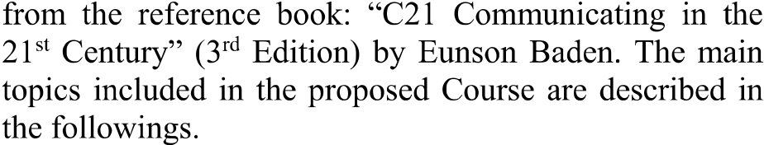











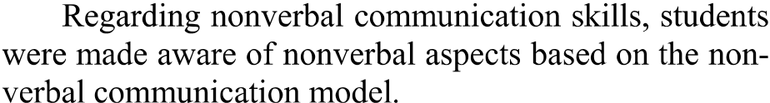





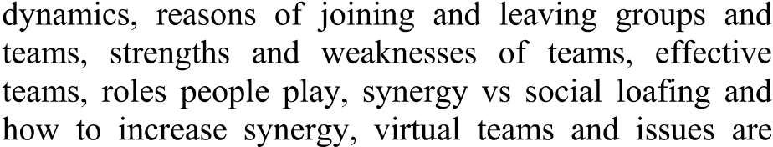



|  |  |  |
| --- | --- | --- |
|  |  |  |















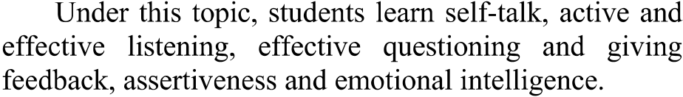



















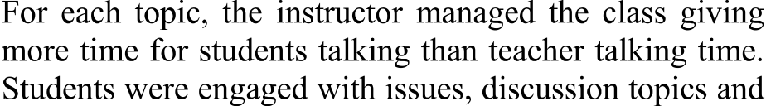

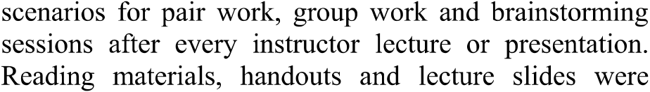



































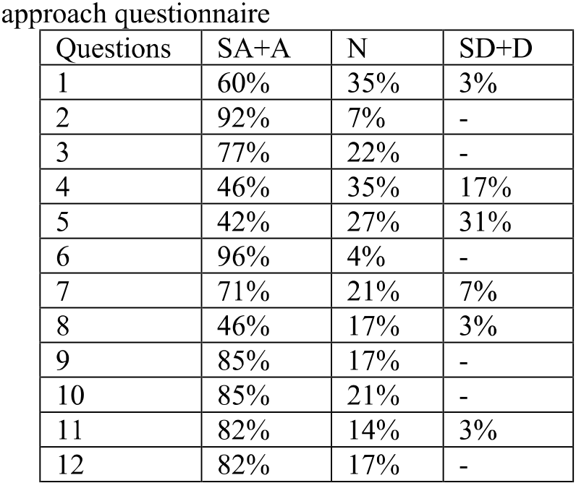



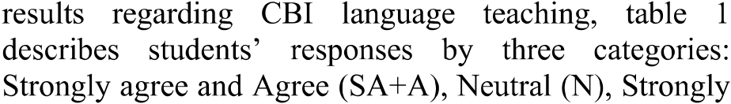









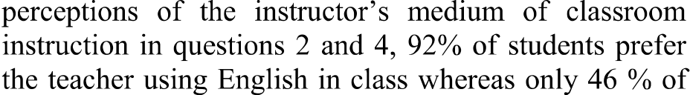

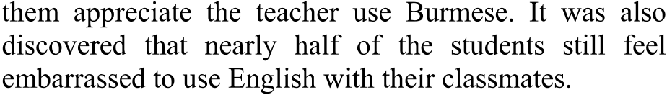







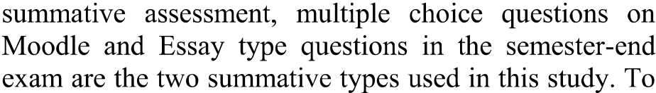



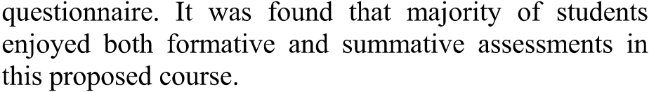



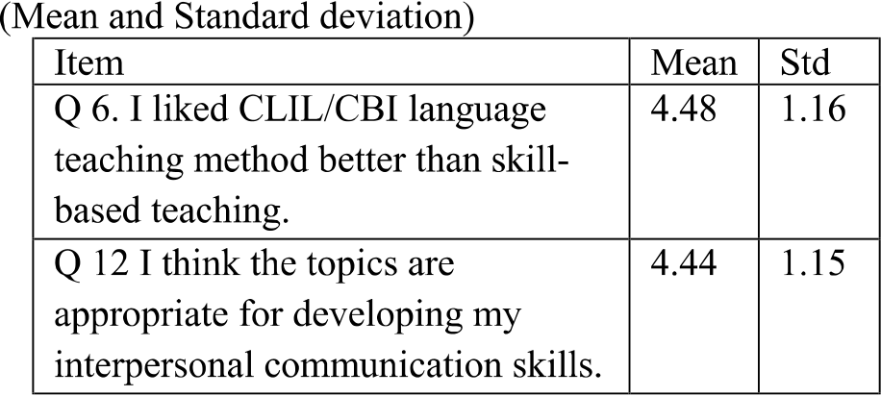

































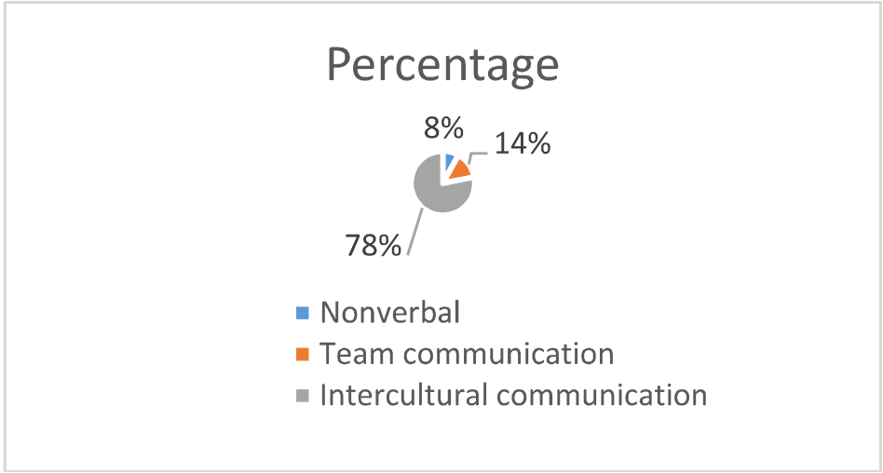







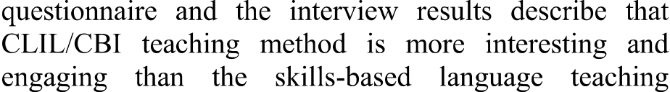









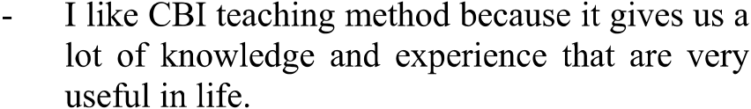



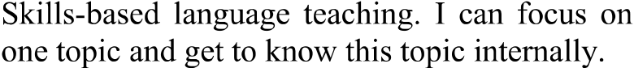

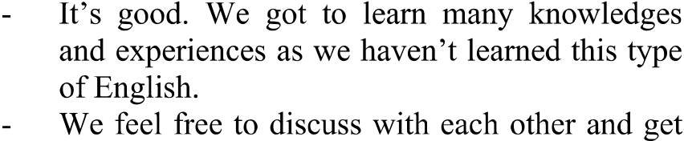





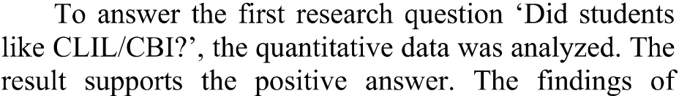



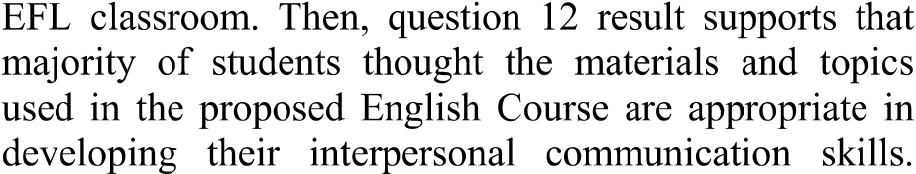



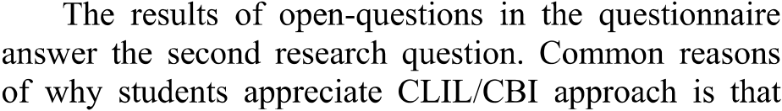





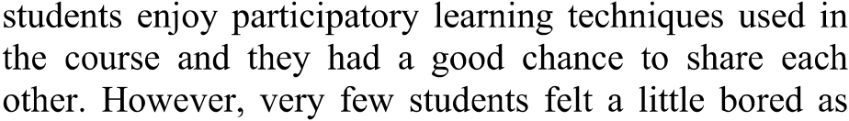





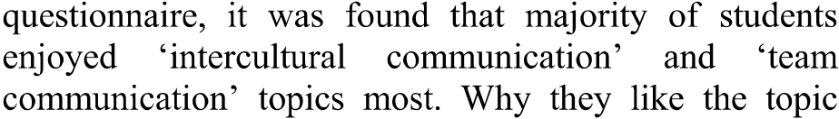

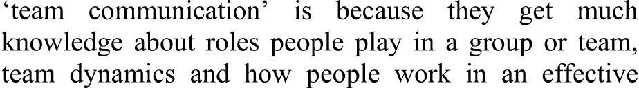

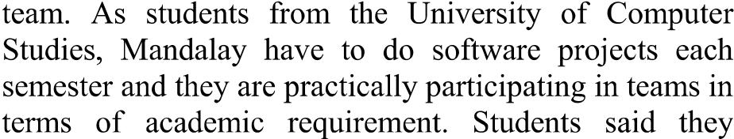



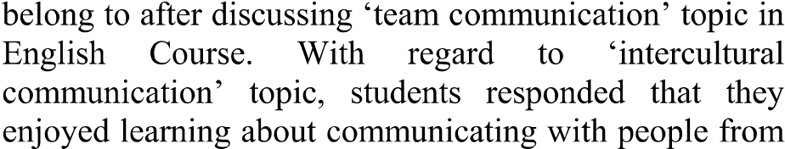



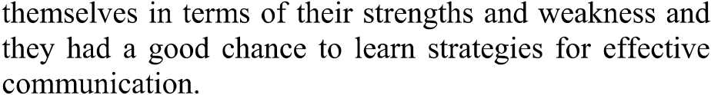





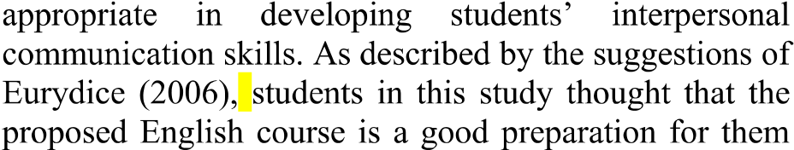



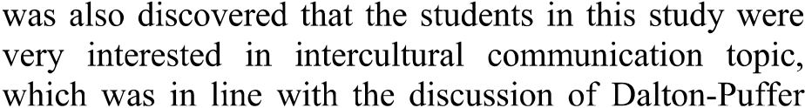





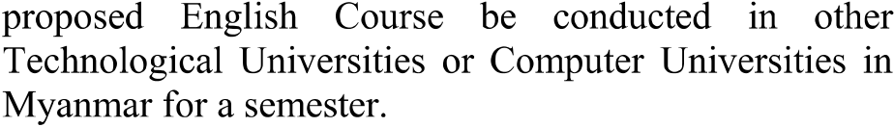





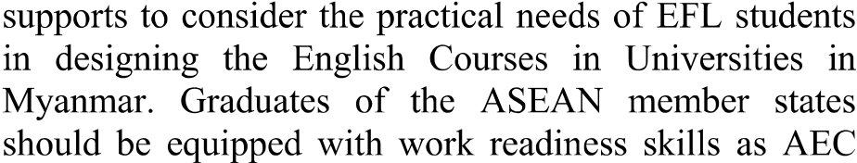















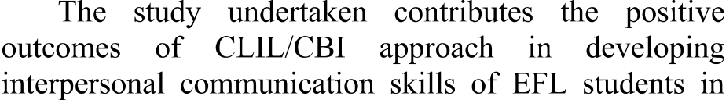

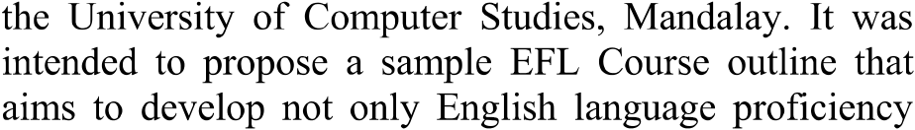

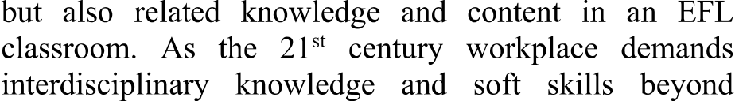

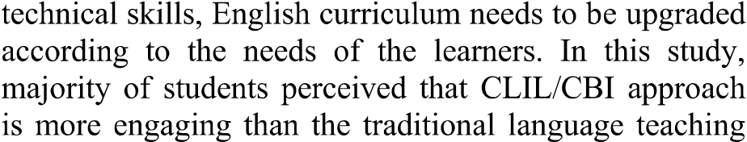



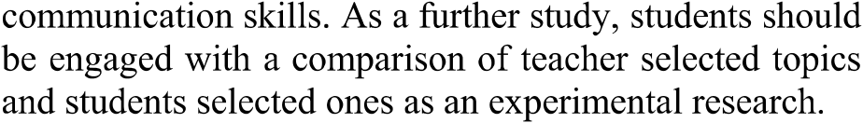









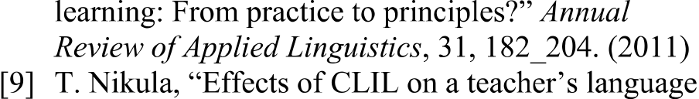

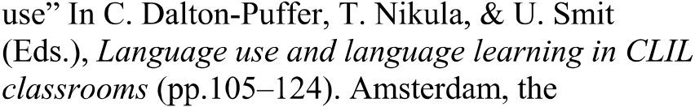

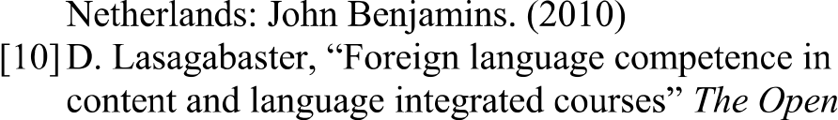















 











































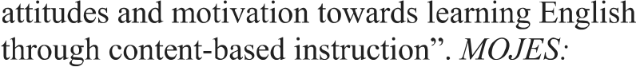



















































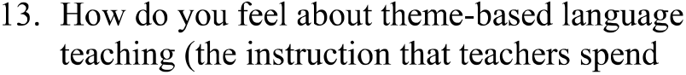



View publication stats





